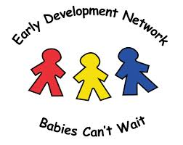
Do you have questions or concerns regarding your child’s development?

The Early Development Network helps support families of children birth
to age 3 who may have a developmental delay or diagnosed disability.
Call: (402) 287-2061 OR contact your school
Visit: http://www.esu1.org/early-development-network/

